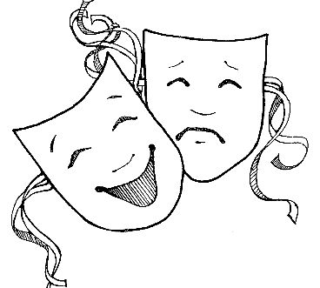
READERS THEATER RESOURCES
12 Fabulously Funny Fairy Tale Plays by Justin Martin

Frantic Frogs and Other Frankly Fractured Folktales for Readers Theatre by Anthony Fredericks

Folk & Fairy Tale Plays for Building Fluency by Carol Pugliano-Martin Scholastic

Tall Tales Read-Aloud Plays by Carol Pugliano-Martin Scholastic

Snow White and the Seven Dorks – A Readers’ Theater Script and Guide by Nancy Wallace

The Princess and the Frog – A Readers’ Theater Script and Guide by Nancy Wallace

The Princedom of Pea – A Readers’ Theater Script and Guide by Nancy Wallace

*There are a lot of picture book fairytale knockoffs that would be great adapted as a Readers’ Theater, such as Falling for Rapunzel by Leah Wilcox

Library Links magazine has Reader’s Theater scripts (this magazine is discontinued after the May-June 2016 issue. Look for old issues)
Other kid’s magazines at your library may have scripts.

Online
Stories on Stage – Scripts for Readers’ Theater by Aaron Shepard
http://www.aaronshep.com/index.html#rt
http://www.aaronshep.com/extras/index.html#Larry

https://www.readinga-z.com/fluency/readers-theater-scripts/

More word play ideas

Mirror Mirror by Marilyn Singer—a poetry book (former Beehive poetry nominee) Fairytales from 2 different perspectives each, written in reverse and still making sense.

J811.54 Whipple, Laura If the Shoe Fits Voices from Cinderella c2002

Mad Libs—use abbreviated fairytales leaving parts blank to be filled in with new nouns, action verbs, adjectives, names…. Then read the silly story aloud

The Skit Book- 101 Skits From Kids by Margaret Read MacDonald
______________________
Story Stretchers for the Primary Grades – Activities to Expand Children’s Books by Shirley Raines and Brian Smith
(especially Chapter 18 Fractured Fairy Tales and Stories With a Twist)

*Check your local library for other resources.

HAVE FUN!
Annie Eastmond 2016

