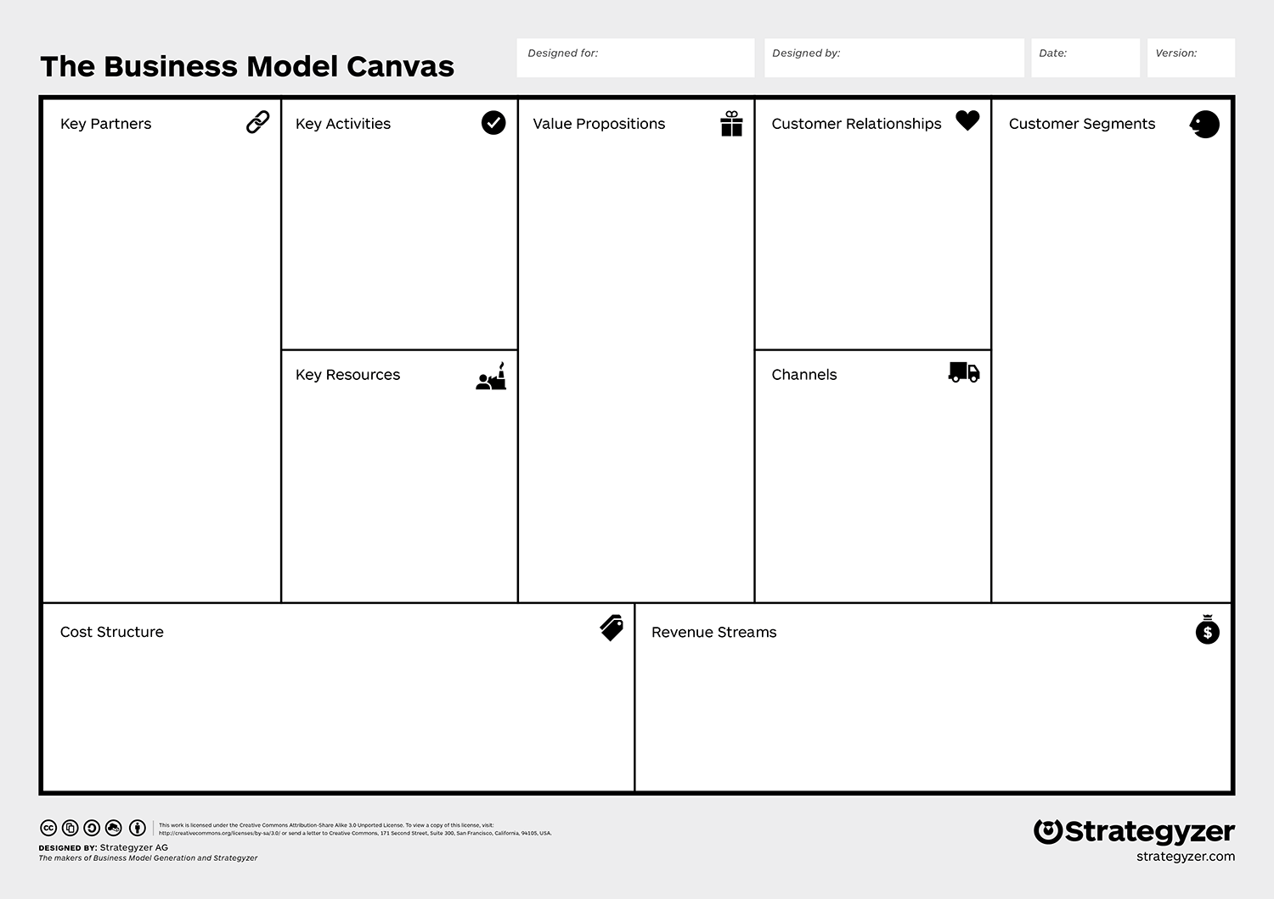**LEAN** **CANVAS** **MODEL**

How much will you make?

What will it cost?

How do you reach them?

What do you need?

Who do you help? 

How do you interact?

**Start Here!**

What do you do?

How do you do it?

Who will help you?

SOURCES: <http://diytoolkit.org/media/Business-Model-Canvasb.jpg> & <https://strategyzer.com/canvas/business-model-canvas>