Utah Public Libraries- Branches
(alphabetical by City)
Last updated 10/31/16
City | Library | Address | Zip | Phone | Email & Website | Hours
Alta | Salt Lake County Library - Alta Reading Room  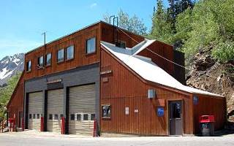 | Alta Community Center  (Across from Rustler Center) | 84121 | (801) 943-4636 | No email listed  http://www.slcolibrary.org/gl/glal/libraryalta.htm | M-Sa 8:30a-12:30p
American Fork | American Fork City Library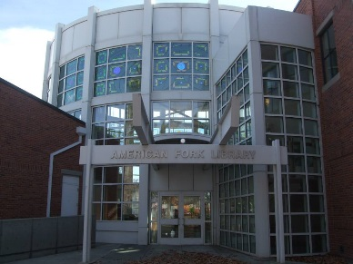 | 64 South 100 East | 84003 | (801) 763-3070 | aflibrary@afcity.net  http://afcity.org/203/Library | M - Th  9 a.m. - 9 p.m.  F&Sa  10 a.m. - 6 p.m.  Closed Holidays
Beaver | Beaver Public Library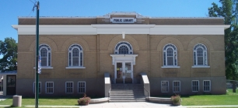 | P.O. Box 192  55 West Center Street | 84713 | (435) 438-5274 | bvlibrary@beaverutah.net  http://www.beaverutah.net/library/ | Winter (Oct – Apr)  Mon 10-6  Tu-Th 11-6  Sat 11-3  Summer  (May-Sept)  M-Th 10-6  F & Sat 11-3
Bicknell | Piute County & Sevier County & Wayne County Bookmobile Library (and Antimony in Garfield Co.)  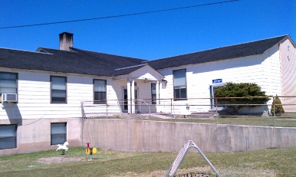 | 79 North 100 West  P.O. Box 250 | 84715 | (435) 425-3170 | tricountybookmobile@utah.gov  http://bookmobiles.utah.gov/tri/ | M-Th 1p-6:30p  Stops vary  depending on  time of year
Blanding | San Juan County Library - Blanding Branch Library  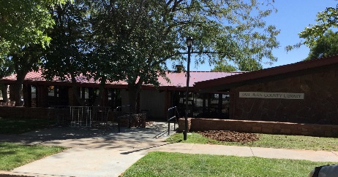 | 25 West 300 South | 84511 | (435) 678-2335 | No email listed; Message box provided. http://www.sanjuancountylibrary.org/ | M-F 11-7  Sat 11-3
Bluff | San Juan County Library - Bluff Branch Library  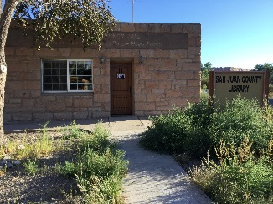 | 480 Black Locust Ave |  | (435) 672-2203 | No email listed; Message box provided.  http://www.sanjuancountylibrary.org/ | Tu & Th 12p-6p
Bountiful | Davis County Library - South Branch (Bountiful)  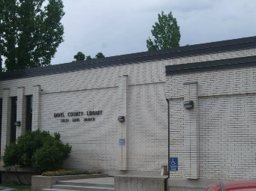 | 725 S Main St. | 84010 | (801) 295-8732 | library@daviscountyutah.gov  http://www.daviscountyutah.gov/library/library/locations/bountiful-branch | M-Th 10am-9pm  Fri & Sat 10a-6p
Brigham City | Brigham City Library  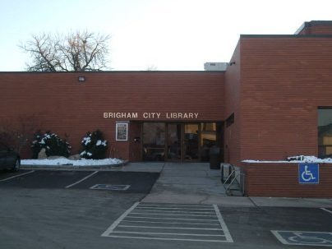 | 26 East Forest Street | 84302 | (435) 723-5850 | brighamlibrary@gmail.com  http://bcpl.lib.ut.us/ | M-Th 10a-8:50p  F&S 10a-5:50p
Castle Dale | Emery County Library - Castle Dale Branch  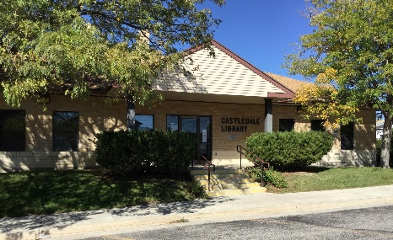 | 135 North 100 East  P.O. Box 515 | 84513 | (435) 381-2554 | cd@lib.emerycounty.com  http://lib.emerycounty.com/castle-dale.html | M-W, F 9:30a-  5:30p  Th 9:30a-6p  Sat 9:30a-5p
Cedar City | Cedar City Public Library  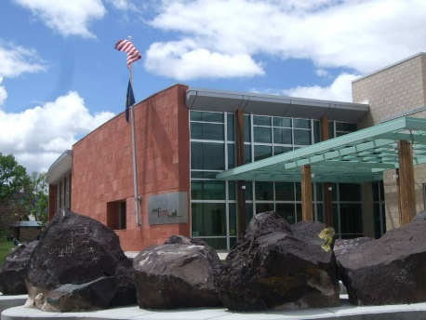 | 303 North 100 East | 84720 | (435) 586-6661 | No email listed  http://www.youseemore.com/cedarcity/default.asp | M-Th 9a-9p  F&Sat 9a-6p
Centerville | Davis County Library - Centerville Branch  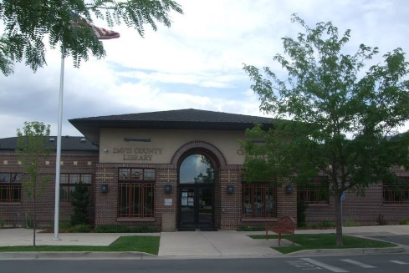 | 45 S. 400 W. | 84014 | (801) 294-4054 | library@daviscountyutah.gov  http://www.daviscountyutah.gov/library/library/locations/centerville-branch | M-Th 10am-9pm  Fri & Sat 10a-6p
Clearfield | Davis County Library - North Branch (Clearfield)  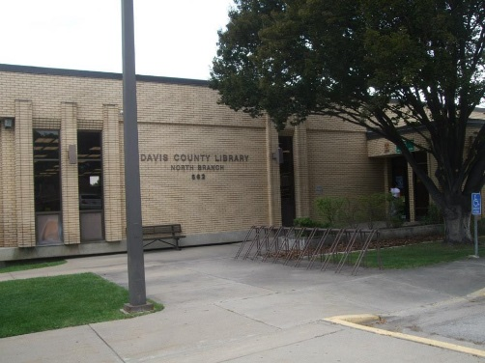 | 562 S 1000 E | 84015 | (801) 825-6662 | library@daviscountyutah.gov  http://www.daviscountyutah.gov/library/library/locations/clearfield-branch | M-Th 10am-9pm  Fri & Sat 10a-6p
Cleveland | Emery County Library - Cleveland Branch  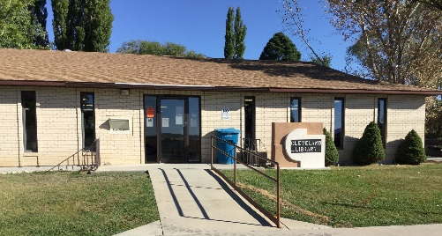 | 60 West Main  PO Box 275 | 84518 | (435) 653-2204 | cl@lib.emerycounty.com  http://lib.emerycounty.com/cleveland.html | M 9:30a-6p  Tu-F 9:30a-5:30p
Coalville | Summit County Library - Coalville Branch Library | 82 N. 50 E. | 84017 | (435) 336-3070 | No branch specific email, but list of managers’ emails  http://www.youseemore.com/SummitCounty/contentpages.asp?loc=50  http://www.youseemore.com/SummitCounty/directory.asp?dir=23 | M-F 10a-6p  Sat 10a-2p
Cottonwood Heights | Salt Lake County Library - Whitmore Library 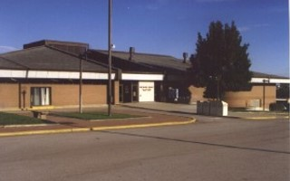 | 2197 East Fort Union Boulevard | 84121 | (801) 943-4636 | No email listed  http://www.slcolibrary.org/gl/glal/libraryWhitmore.htm | M-Th 10a-9p;  F&Sat 10a-6p
Delta | Delta City Library  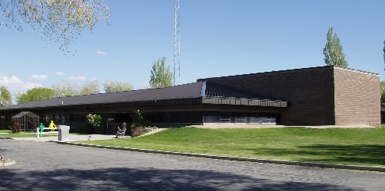 | 76 North 200 West | 84624 | (435) 864-4945 | No branch email; director’s email: dgreathouse@delta.utah.gov  http://www.delta.utah.gov/citylibrary.main.html | M, T, Th 2p-8p  W 11a-8p  F 2p-6p  Sat 1p-5pm
Delta | Millard County/West Central Utah Bookmobile Library | (In Delta Library)  90 North 200 West | 84624 | (435) 864-2292 | millardwestcentralutahbookmobile@utah.gov  http://bookmobiles.utah.gov/millard/ | M-Th 8:30a-12p;  1p-3p
Draper | Salt Lake County Library - Draper Library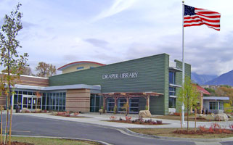 | 1136 East Pioneer Rd (124th South) | 84020 | (801) 943-4636 | No email listed  http://www.slcolibrary.org/gl/glal/librarydraper.htm | M-Th 10a-9p;  F&Sat 10a-6p
Duchesne | Daggett County Bookmobile Library - Discontinued | 130 South Center Street, Suite A | 84021 | (435) 738-2628 | DISCONTINUED PERMANENTLY (according to website)
Duchesne | Duchesne County Library  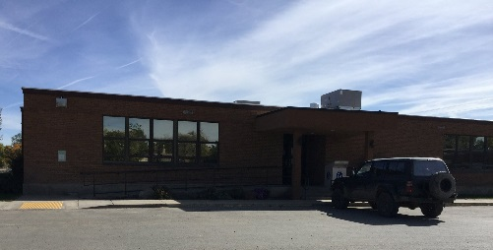 | 130 S Center Street | 84021 | (435) 738-2800 | No branch email; director’s email: dmauchley@duchesne.utah.gov  https://www.duchesne.utah.gov/your-government-2/county-departments/library/duchesne-library/ | M-Th 10a-6p  F & Sat 10a-5p
Eagle Mountain | Eagle Mountain Public Library  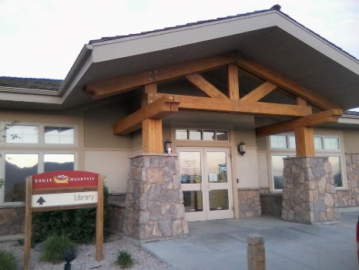 | 1650 E. Stagecoach Run | 84005 | (801) 789-6623 | libraryeaglemtn@gmail.com  http://www.eaglemountaincity.org/departments/library | M&W 10a-6:30p  T&Th 10a-7p  F&Sat 10a-2p
East Millcreek | Salt Lake County Library -Millcreek Community Library 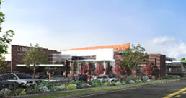 | 2266 E. Evergreen Avenue | 84109 | (801) 943-4636 | No email listed  http://www.slcolibrary.org/gl/glal/libraryMillcreek.htm | M-Th 10a-9p;  F&Sat 10a-6p
Elmo | Emery County Library - Elmo Branch  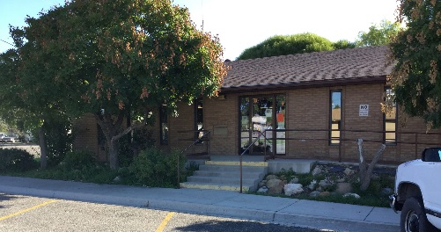 | 100 East Main  PO Box 217 | 84521 | (435) 653-2558 | el@lib.emerycounty.com  http://lib.emerycounty.com/elmo.html | M-W, F 9:30a-  5:30p  Th 9:30a-6p
Emery | Emery County Library - Emery Branch  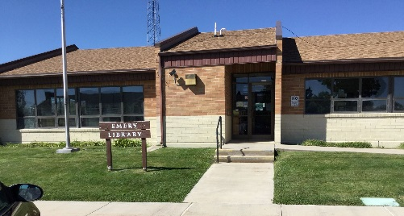 | 85 North Center  PO Box 127 | 84522 | (435) 286-2474 | em@lib.emerycounty.com  http://lib.emerycounty.com/emery.html | M 9:30a-6p  Tu-Th 9:30a-  5:30p
Enoch | Iron County Bookmobile Library | 4763 North Santa Fe Trail | 84720 | (435) 586-6715 | ironcountybookmobile@utah.gov  http://bookmobiles.utah.gov/iron/  https://www.facebook.com/IronCountyBookmobile/?fref=nf | M&W 12p-5p  Tu 10a-3p  Th 12p-7p
Enterprise | Washington County Library - Enterprise Branch  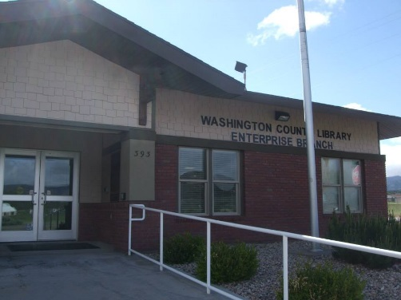 | 393 South 200 East  PO Box 160 | 84725 | (435) 878-2574 | No email listed  http://library.washco.utah.gov/enterprise/ | M & F 10a-6p  T-Th 10a-7p  Sat 10a-3p
Ephraim | Ephraim Public Library  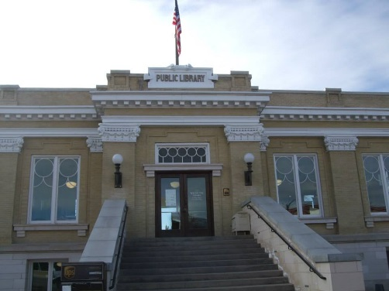 | 30 South Main Street | 84627 | (435) 283-4544 | No branch email; director’s email: lori.voshall@ephraimcity.org  http://ephraimcity.org/155/Library | M-F 11a-9p  Sat 10a – 2p
Fairview | Sanpete/Southern Juab County Bookmobile Library | 75 South State Street | 84629 | (435) 427-9305 | sanpetejuabbookmobile@utah.gov  http://bookmobiles.utah.gov/sanpete/  https://www.facebook.com/SanpeteCountyBookmobile/?fref=nf | M-W 10a-4:30p  Thu 10a-2p
Farmington | Davis County Library - Headquarters (Farmington)  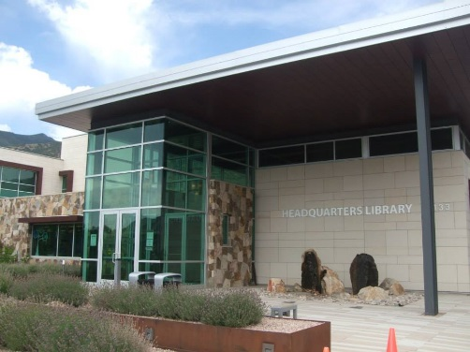 | 133 S. Main Street | 84025 | (801) 451-3030 | library@daviscountyutah.gov  http://www.daviscountyutah.gov/library/library/locations/farmington-branch | M-Th 10am-9pm  Fri & Sat 10a-6p
Ferron | Emery County Library - Ferron Branch  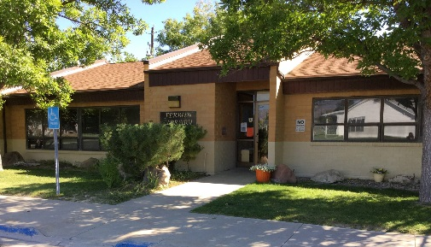 | 90 North 200 West  PO Box 850 | 84523 | (435) 384-2637 | fe@lib.emerycounty.com  http://lib.emerycounty.com/ferron.html | M,T,Th,F 9:30a-  5:30p  W 9:30a-6p
Fillmore | President Millard Fillmore Library  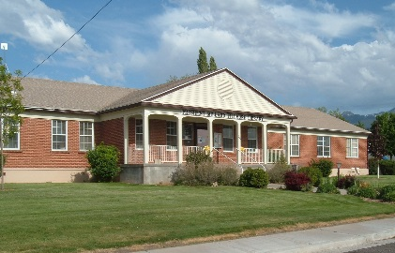 | 25 South 100 West | 84631 | (435) 743-5314 | info@fillmorelibrary.org  http://www.fillmorelibrary.org/ | M-Th 10a-6p  F 10a-5p  Sat 9a-1p
Garland | Garland Public Library  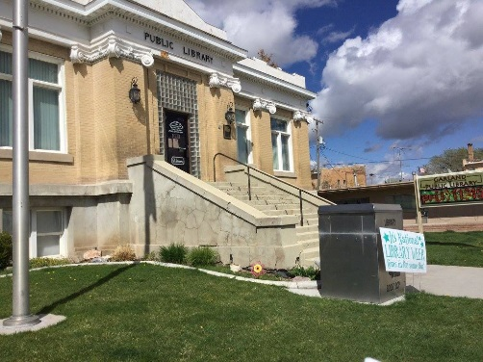 | 86 West Factory St | 84312 | (435) 257-3117 | library@garlandutah.org  http://garlandlibrary.org/ | M & Sat 10a-2p  T-Th 10a-7p  F 10a-6p
Grantsville | Tooele County Bookmobile Library | 429 East Main St.  PO Box 1154 | 84029 | (435) 884-3703 | No email listed  http://librarytechnology.org/libraries/library.pl?id=24912
Green River | Emery County Library - Green River Branch  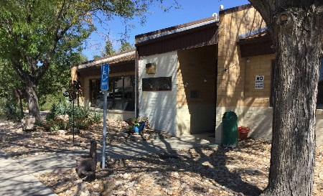 | 85 South Long St.  PO Box 510 | 84525 | (435) 564-3349 | gr@lib.emerycounty.com  http://lib.emerycounty.com/green-river.html | M,W-F 9:30a-  5:30p  Tu 9:30a-6p
Gunnison | Gunnison Civic Library  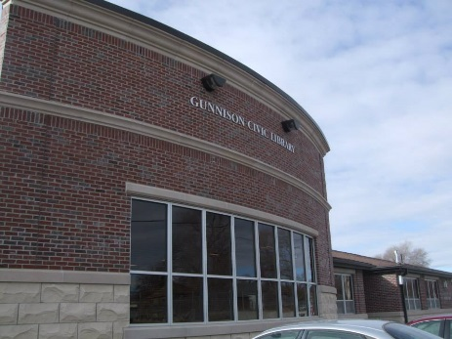 | 38 West Center Street  PO Box 790 | 84634 | (435) 528-3104 | info@gunnisoncity.org  http://www.gunnisoncity.org/library-32.htm | M 11a-5p  T&Th&F 1p-7p  W 11a-7p  Sat 10a-2p
Heber City | Wasatch County Library  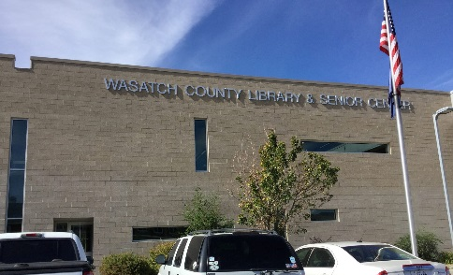 | 465 East 1200 South | 84032 | (435) 654-1511 | No branch email; director’s email: kbowcutt@co.wasatch.ut.us  http://www.wasatch.lib.ut.us/ | M-F 9:30a-8p  Sat 9:30a-1:30p
Helper | Helper City Library  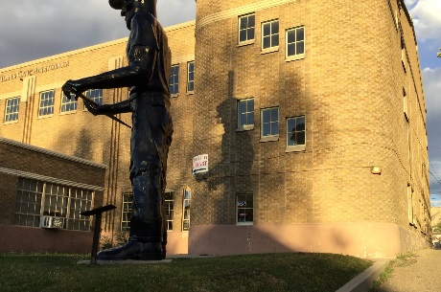 | 19 South Main Street | 84526 | (435) 472-5601 | helperlibrary@helpercity.net  https://helpercitylibrary.wordpress.com/ | M-Th 10a-7p
Helper | Carbon County Bookmobile Library | 19 South Main Street  (In Helper Library) | 84526 | (435) 472-0638 | carboncountybookmobile@utah.gov  http://bookmobiles.utah.gov/carbon/ | M-Th 10a-7p
Herriman | Salt Lake County Library - Herriman Library 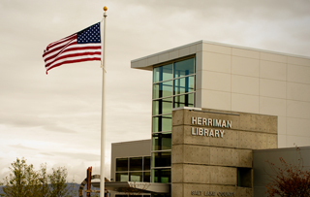 | 5380 West Herriman Main Street | 84096 | (801) 943-4636 | No email listed  http://www.slcolibrary.org/gl/glal/libraryHerriman.htm | M-Th 10a-9p;  F&Sat 10a-6p
Holladay | Salt Lake County Library - Holladay Library 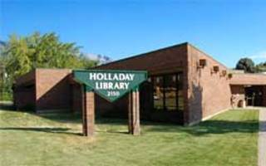 | 2150 East Murray-Holladay Rd | 84117 | (801) 943-4636 | No email listed  http://www.slcolibrary.org/gl/glal/libraryHolladay.htm | M-Th 10a-9p;  F&Sat 10a-6p
Huntington | Emery County Library - Huntington Branch  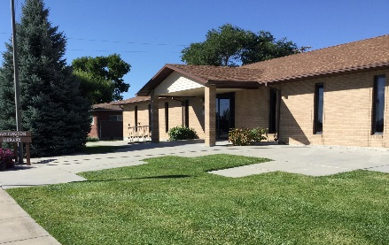 | 70 South Main  PO Box 794 | 84528 | (435) 687-9590 | hu@lib.emerycounty.com  http://lib.emerycounty.com/huntington.html | M,T,Th,F 9:30a-  5:30p  W 9:30a-6p
Huntsville | Weber County Library - Ogden Valley Branch  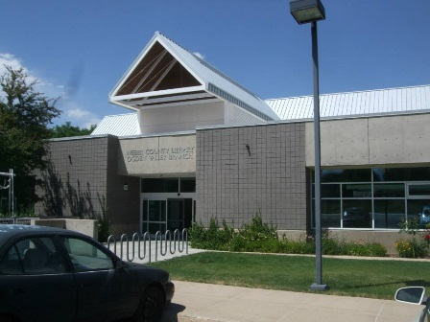 | 131 S 7400 E | 84317 | (801) 337-2660 | No email listed  http://www.weberpl.lib.ut.us/location/ogden-valley-branch | M-Th 10a-9p  F-Sat 10a-6p  Sun 1p-5p  (Sep-May)
Hurricane | Washington County Library - Hurricane Branch  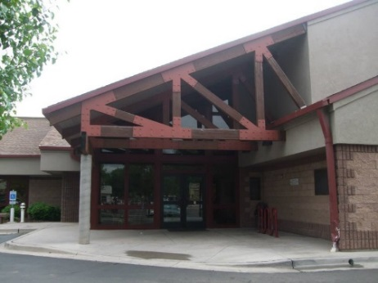 | 36 South 300 West | 84737 | (435) 635-4621 | No email listed  http://library.washco.utah.gov/hurricane/ | M-Th 10a-7p  F&sSat 10a-6p
Hyrum | Hyrum Library  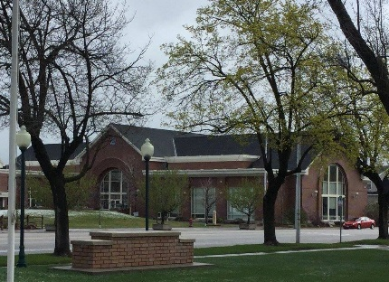 | 50 West Main Street | 84319 | (435) 245-6411 | hyrumlibrary@gmail.com  http://hyrumlibrary.com/ | M-F 10a-7p  Sat 10a-3p
Kamas | Summit County Library - Kamas Branch Library  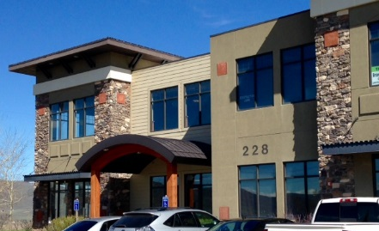 | 228 W. 200 S. Ste 2B | 84036 | (435) 783-3190 | No branch specific email, but list of managers’ emails  http://www.youseemore.com/SummitCounty/contentpages.asp?loc=50  http://www.youseemore.com/SummitCounty/directory.asp?dir=24 | M-F 10a-6p
Kanab | Kanab City Library  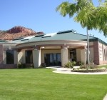 | 374 North Main Street | 84741 | (435) 644-2394 | kancitlib@xpressweb.com  http://www.kanablibrary.org/ | M&F 10a-5p  T-Th 10a-7p  Sat 10a-2p
Kaysville | Davis County Library - Kaysville Branch  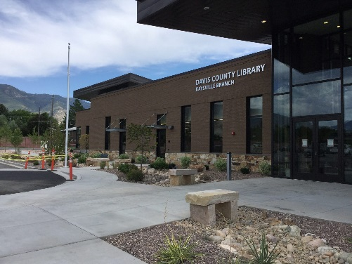 | 215 N. Fairfield Rd | 84037 | (801) 444-2250 | library@daviscountyutah.gov  http://www.daviscountyutah.gov/library/library/locations/kaysville-library | M-Th 10am-9pm  Fri & Sat 10a-6p
Kearns | Salt Lake County Library - Kearns Library 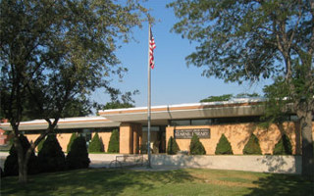 | 5350 South 4220 West | 84118 | (801) 943-4636 | No email listed  http://www.slcolibrary.org/gl/glal/libraryKearns.htm | M-Th 10a-9p;  F&Sat 10a-6p
La Sal | San Juan County Library – La Sal Branch Library  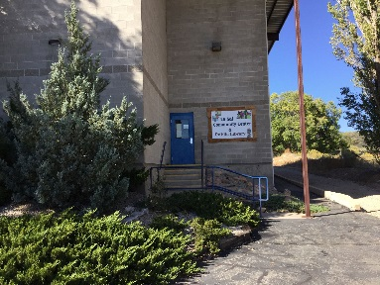 | Inside La Sal Community Center @ Hwy 46 |  | 435-686-9936 | No email listed; Message box provided.  http://www.sanjuancountylibrary.org/ | Tu & Th 12p-6p
Layton | Davis County Library - Central Branch (Layton)  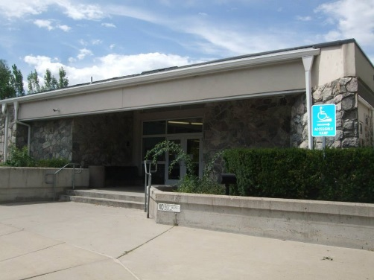 | 155 N. Wasatch Dr. | 84041 | (801) 547-0729 | library@daviscountyutah.gov  http://www.daviscountyutah.gov/library/library/locations/layton-branch | M-Th 10am-9pm  Fri & Sat 10a-6p
Lehi | Lehi City Public Library  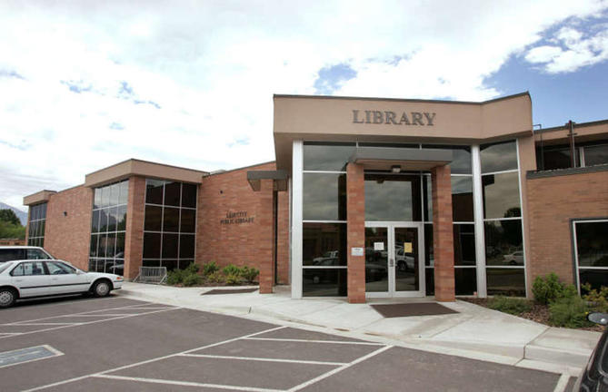 | 120 North Center Street | 84043 | (385) 201-1050 | No email listed  https://www.lehi-ut.gov/recreation/library/ | M-Th 9a-9p  F&Sat 10a-6p
Lewiston | Lewiston Public Library  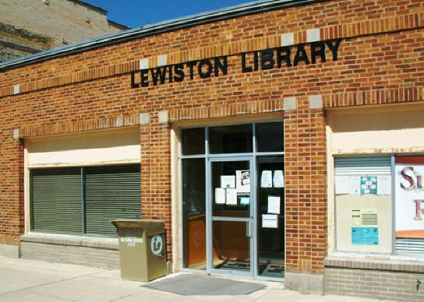 | 33 South Main Street | 84320 | (435) 258-5515 | mhall@lewiston-ut.org  http://www.lewiston-ut.org/Library.html | M & Th 10a-5p  T 10a-7p  W 9a-1p, 6p-9p  F&Sat 10a-3p
Logan | Logan Library  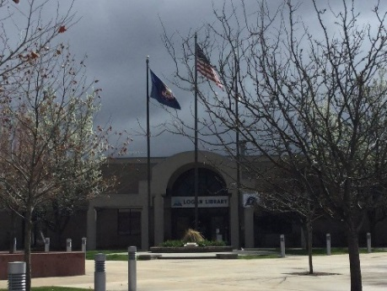 | 255 North Main Street | 84321 | (435) 716-9123 | No email listed; message box provided  http://library.loganutah.org/ | M-Th 10a-9p  F-Sat 10a-6p
Magna | Salt Lake County Library - Magna Library 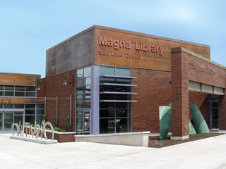 | 2675 South, 8950 West | 84044 | (801) 943-4636 | No email listed  http://www.slcolibrary.org/gl/glal/libraryMagna.htm | M-Th 10a-9p;  F&Sat 10a-6p
Manti | Manti City Library  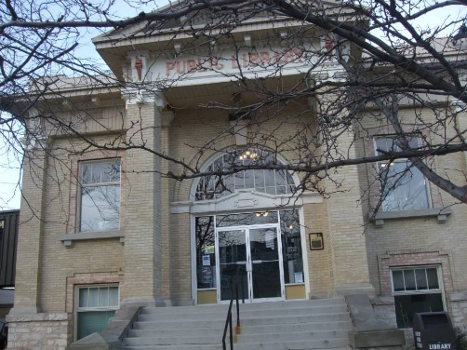 | 50 South Main Street, Suite 1 | 84642 | (435) 835-2201 | No email listed  http://mantiutah.org/library.html | M-F 10a-7p  Sat 10a-3p
Mapleton | Utah/Northern Juab County Bookmobile Library | 125 West 400 North | 84664 | (801) 489-4833 | utahjuabbookmobile@utah.gov  http://bookmobiles.utah.gov/utah/ | M-Th 10a-12:30p,  1p-8p  F 10a-5p
Midvale | Salt Lake County Library – (Ruth Vine) Tyler Library 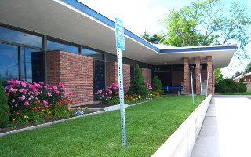 | 8041 South Wood Street (55 West) | 84047 | (801) 943-4636 | No email listed  http://www.slcolibrary.org/gl/glal/libraryTyler.htm | M-Th 10a-9p;  F&Sat 10a-6p
Milford | Milford Public Library  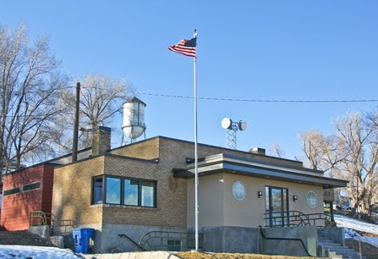 | 400 South 100 West  PO Box 69 | 84751 | (435) 387-5039 | library@milford.utah.gov  http://www.milfordut.com/library.main.html | M-F 11a-6p  Sat 11a-4p
Minersville | Minersville Public Library | 40 West Main Street | 84752 | (435) 386-2267 | minersvillelibrary@gmail.com  https://heritage.utah.gov/apps/library/library_directory/library.php?libraryid=34 (click website link on that site) | M,T,&Th 1p-7p  W 1p-6p  F 1p-5p
Moab | Grand County Public Library  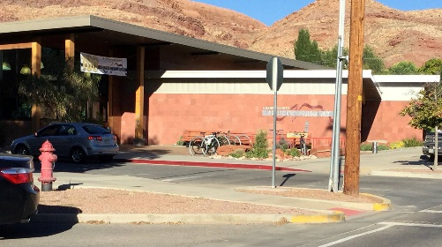 | 257 East Center St | 84532 | (435) 259-1111 | info@moablibrary.org  http://www.moablibrary.org/ | M-F 9a-8p  Sat 9a-5p
Monroe | Monroe Public Library  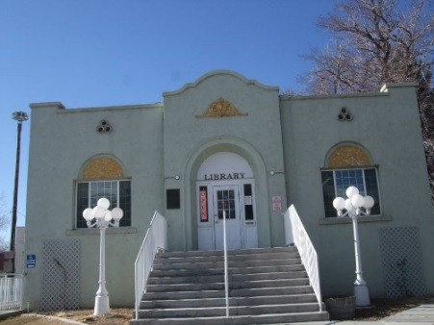 | 55 North Main Street  PO Box 120 | 84754 | (435) 527-4019 | monroedirector@yahoo.com  https://heritage.utah.gov/apps/library/library_directory/library.php?libraryid=35 (click website link on that site) | T-Sat 1p-6p
Montezuma Creek | San Juan County Library – Montezuma Creek Branch Library  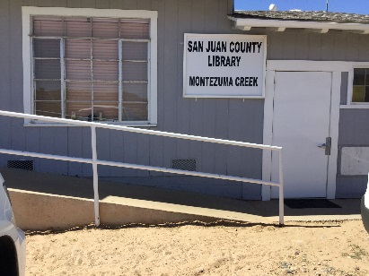 | 5th East Street |  | 435-651-3309 | No email listed; Message box provided.  http://www.sanjuancountylibrary.org/ | M, W, & F 12p-6p
Monticello | San Juan County Bookmobile Library | 835 E Highway 666 | 84535 | (435) 587-2335 | No email listed; Message box provided.  No website given. Use county system’s site: http://www.sanjuancountylibrary.org/
Monticello | San Juan County Library - Monticello Branch Library  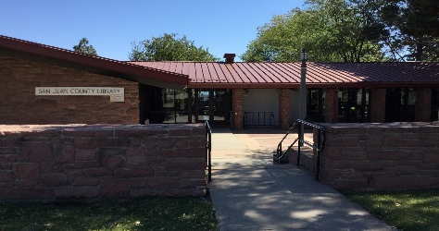 | 80 N Main | 84535 | (435) 587-2281 | No email listed; Message box provided.  http://www.sanjuancountylibrary.org/ | M-F 11-7  Sat 11-3
Morgan | Morgan County Library  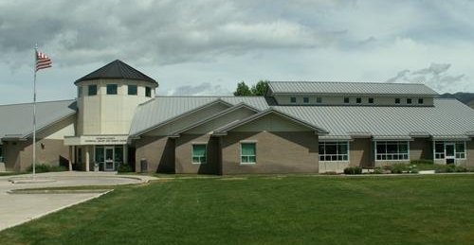 | 50 North 100 West | 84050 | (801) 829-3481 | Link for Director’s email on website under Contact Us  http://library.morgan-county.net/ | M-Th 11a-7p  F 11a-5p  Sat 12p-5p
Mt. Pleasant | Mt. Pleasant Public Library  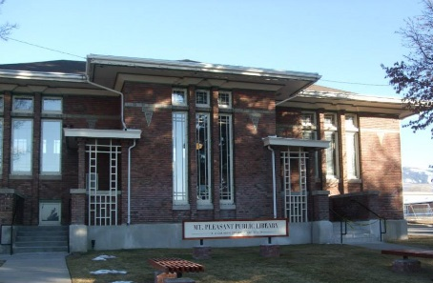 | 24 East Main Street | 84647 | (435) 462-3240 | library@mtpleasantcity.com  http://mtpleasantlib.org/ | M&F 11a-5p  T-Th 11a-7p  Sat 11a-3p
Murray | Murray Public Library  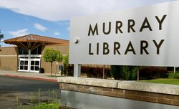 | 166 East 5300 South | 84107 | (801) 264-2580 | No email listed; message box provided  http://www.murraylibrary.org/ | M-Th 10a-9p  F&Sat 10a-6p
Nephi | Nephi Public Library  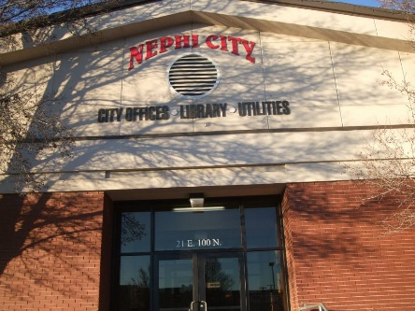 | 21 East 100 North | 84648 | (435) 623-1312 | library@nephi.utah.gov  http://nephi.utah.gov/library/ | M-Th 11a-7p  F 1p-5p  Sat 10a-2p
New Harmony | Washington County Library - New Harmony Branch  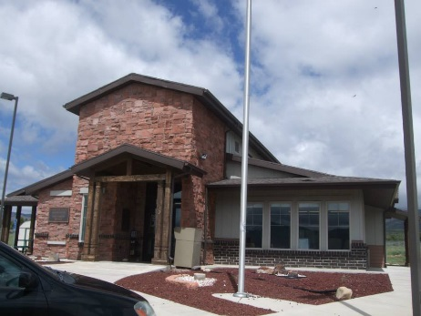 | 34 South 2900 East | 84757 | (435) 867-0065 | No email listed  http://library.washco.utah.gov/new-harmony/ | M-Th 10a-7p  F & Sat 10a-4p
Newton | Newton Town Library  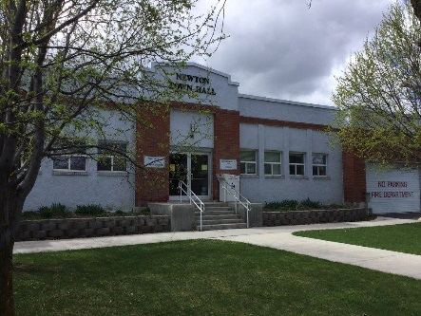 | 51 South Center Street | 84327 | (435) 563-9283 | No email listed  http://www.newtontownlibrary.com/ | M 3p-7p  T&Th 10a-1p;  3p-6p  W 3p-6p  Sat 12p-4p
North Logan | North Logan City Library  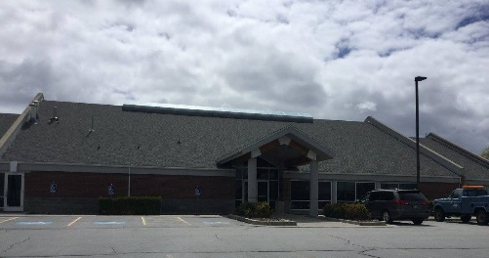 | 475 East 2500 North | 84341 | (435) 755-7169 | No email listed  http://www.northloganlibrary.org/ | M&Sat 12p-4p  T-F10a-7p
Ogden | Weber County Library  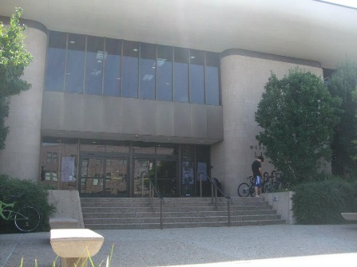 | 2464 Jefferson Avenue | 84401 | (801) 337-2632 | No email listed  http://www.weberpl.lib.ut.us/location/main-library | M-Th 10a-9p  F-Sat 10a-6p  Sun 1p-5p  (Sep-May)
Ogden | Weber County Library - Law Library  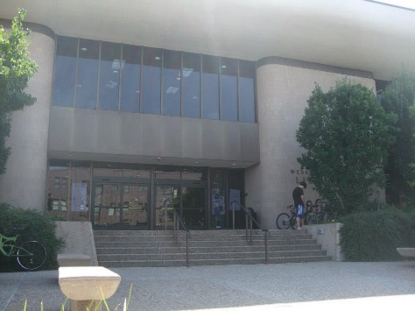 | 2464 Jefferson Ave. | 84401 | (801) 337-2645 | No email listed  http://www.weberpl.lib.ut.us/location/law-library | M-Th 10a-9p  F-Sat 10a-6p  Sun 1p-5p  (Sep-May)
Ogden (North) | Weber County Library - North Branch  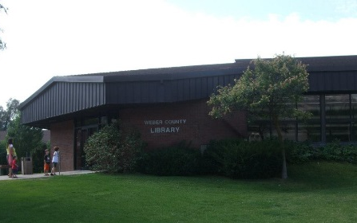 | 475 E 2600 N | 84414 | (801) 337-2650 | No email listed  http://www.weberpl.lib.ut.us/location/north-branch | M-Th 10a-9p  F-Sat 10a-6p  Sun 1p-5p  (Sep-May)
Ogden | Weber County Library - Pleasant Valley Branch  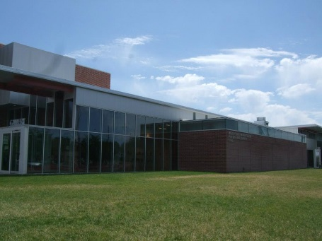 | 5568 S Adams Ave. | 84405 | (801) 337-2690 | No email listed  http://www.weberpl.lib.ut.us/location/pleasant-valley-branch | M-Th 10a-9p  F-Sat 10a-6p  Sun 1p-5p  (Sep-May)
Orangeville | Emery County Library - Orangeville Branch  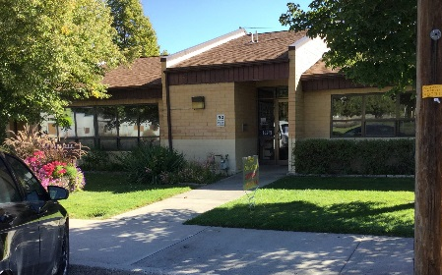 | 115 South Main  PO Box 628 | 84537 | (435) 748-2726 | or@lib.emerycounty.com  http://lib.emerycounty.com/orangeville.html | M, W-F 9:30a-  5:30p  Tu 9:30a-6p
Orem | Orem Public Library  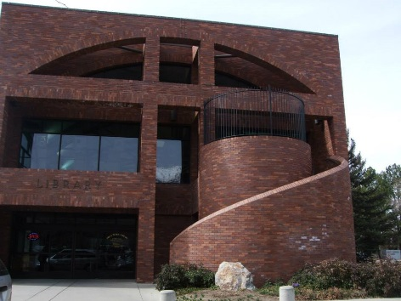 | 58 North State Street | 84057 | (801) 229-7050 | No email listed; message box provided  http://lib.orem.org/ | M-F 9a-8p  Sat 9a-6p
Panguitch | Panguitch City Library  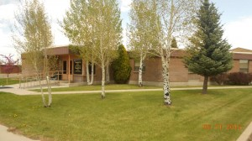 | 25 South 200 East  P.O. Box 75 | 84759 | (435) 676-2431 | No email listed  http://panguitchlibrary.org/ | M,W,F 1p-6p  T&Th 1p-7p
Panguitch | Kane County & Garfield County Bookmobile Library | 25 South 200 East  P.O. Box 805 | 84759 | (435) 676-2431 | multicountybookmobile@utah.gov  http://bookmobiles.utah.gov/multi/index.html | Library 1p–6pm M- W- F 1:00 pm – 7 :00 pm T- TH  BKM Office 9a–4:30p Closed 1:00 pm – 2:00 pm for lunch Monday-Thursday
Park City | Park City Library  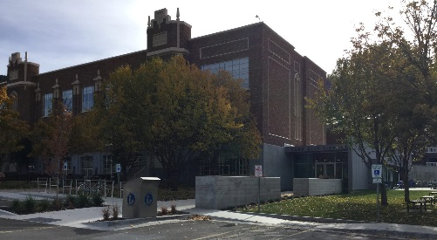 | 1255 Park Avenue  PO Box 668 | 84060 | (435) 615-5600 | No email listed; message box provided; staff emails listed  http://parkcitylibrary.org/ | M-Th 10a-9p  F&Sat 10a-6p  Su 1p-5p
Park City | Summit County Library – Kimball Junction Branch (& Administration)  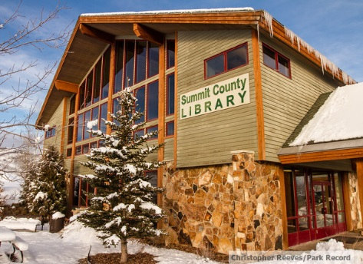 | 1885 W. Ute Blvd | 84098 | (435) 615-3900 | No branch specific email, but list of managers’ emails  http://www.youseemore.com/SummitCounty/contentpages.asp?loc=50  http://www.youseemore.com/SummitCounty/directory.asp?dir=27 | M-Th 10a-8p  Fr & Sat 10a-6p
Parowan | Parowan Public Library  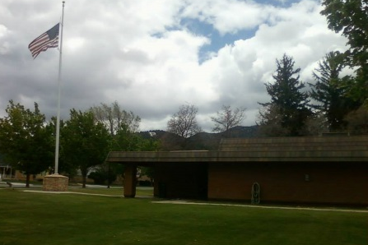 | 16 South Main Street | 84761 | (435) 477-3491 | parowlib@infowest.com  http://parowan.org/parowan-library/ | M-Th 10a-9p  F&Sat 1p-6p
Payson | Payson City Library  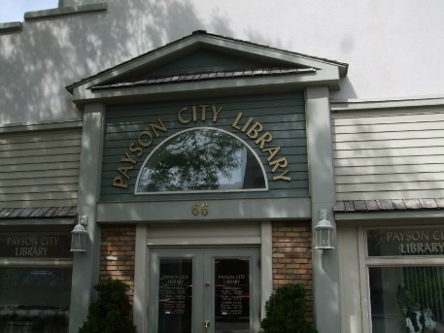 | 66 South Main Street | 84651 | (801) 465-5220 | No branch email; director’s email:  lindac@payson.org  http://www.paysonlibrary.org/ | Winter  M-Th 10a-7:45pm  F&Sa 11a-4:45pm  Summer  M-Th 10a-6:45pm  F&Sa 11a-4:45pm
Pleasant Grove | Pleasant Grove Public Library  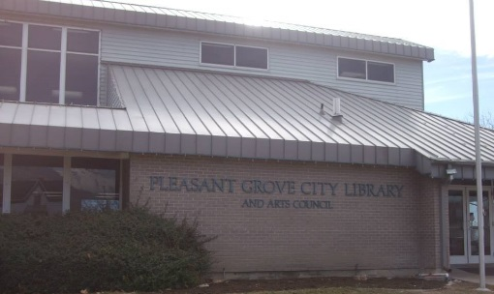 | 30 East Center Street | 84062 | (801) 785-3950 | No email listed  http://library.plgrove.org/ | M-Th 9a-9p  F&Sa 10a-6p
Price | Price City Library  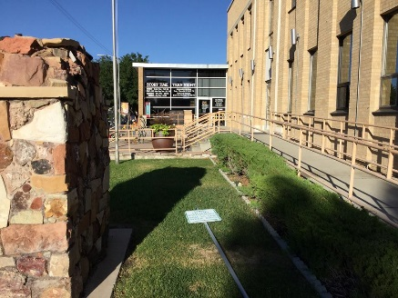 | 159 East Main Street | 84501 | (435) 636-3188 | No email listed  https://www.facebook.com/Price-City-Library-208359129201000/about/  (other weblinks not working) | M-F 8a-7p  Sat 9a-12p
Providence | Cache/Rich County Bookmobile Library  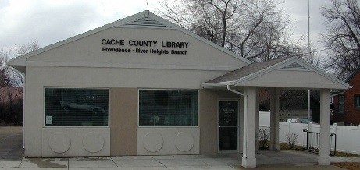 | 15 North Main Street  PO Box 63 | 84332 | (435) 752-7881 | cacherichcountybookmobile@utah.gov  http://bookmobiles.utah.gov/cache/ | M-F 10a-12p,  3p-6:45p  Sat 10a-2p
Provo | Provo City Library  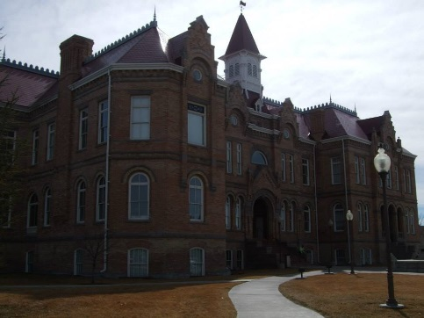 | 550 North University Avenue | 84601 | (801) 852-6650 | webadultreference@provolibrary.com  http://www.provolibrary.com/ | M-F 9a-9p  Sat 9a-6p
Randolph | Rich/Cache County Bookmobile Library | 15 North Main Street  PO Box 63  (Providence) | 84332 | (435) 752-7881 | cacherichcountybookmobile@utah.gov  http://bookmobiles.utah.gov/cache/ | M-F 10a-12p,  3p-6:45p  Sat 10a-2p
Richfield | Richfield Public Library  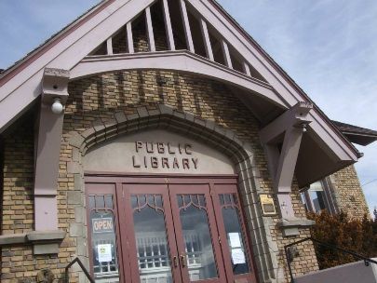 | 83 East Center Street | 84701 | (435) 896-5169 | library@richfieldcity.com  http://www.richfieldlibrary.com/?p=1 | M-Th 11a-7p  Sat 11a-5p
Richmond | Richmond Public Library  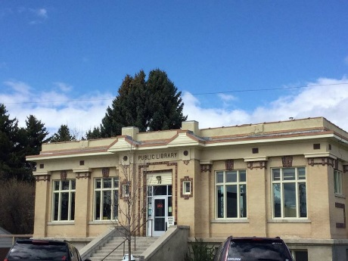 | 38 West Main Street | 84333 | (435) 258-5525 | library@richmond-utah.com  http://richmondlibrary.us/ | M,W,F 2p-6p  T, Th 10a-12p;  2p-8p  Sat 9a-1p
Riverton | Salt Lake County Library - Riverton Library 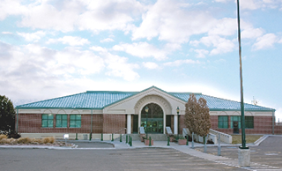 | 12877 South 1830 West | 84065 | (801) 943-4636 | No email listed  http://www.slcolibrary.org/gl/glal/libraryRiverton.htm | M-Th 10a-9p;  F&Sat 10a-6p
Roosevelt | Duchesne County Library - Roosevelt Branch Library  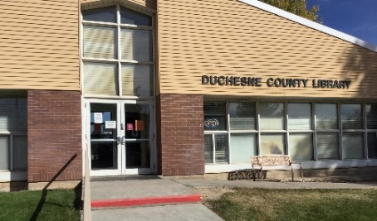 | 70 W Lagoon | 84066 | (435) 722-4441 | No branch email; manager’s email: smoon@duchesne.utah.gov  https://www.duchesne.utah.gov/your-government-2/county-departments/library/roosevelt-library/ | M-Th 10a-7p  S & Sat 10a-5p
Roy | Weber County Library - Southwest Branch  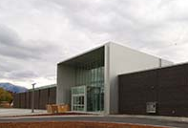 | 2039 W 4000 S | 84067 | (801) 337-2670 | No email listed  http://www.weberpl.lib.ut.us/location/southwest-branch | M-Th 10a-9p  F-Sat 10a-6p  Sun 1p-5p  (Sep-May)
Salem | Salem City Library  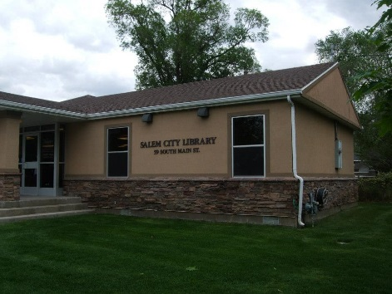 | 59 South Main St | 84653 | (801) 423-2622 | No email listed; message box provided  http://www.salemcitylibrary.org/ | M-Th 10a-7p  F 10a-5p  Sa 10a-2p
Salina | Salina Public Library  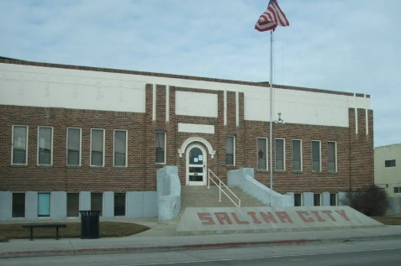 | 90 West Main Street | 84654 | (435) 529-7753 | No email is listed  http://www.salinacity.org/library/ | M-Th 12p-7p  F 12p-5p
Salt Lake City | Salt Lake City Public Library – Main  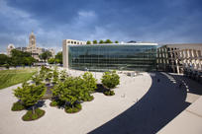 | 210 East 400 South | 84111 | (801) 524-8200 | No email listed; message box provided  http://www.slcpl.org/ | M-Th 9a-9p  F&Sa 9a-6p  Su 1p-5p
Salt Lake City | Salt Lake City Public Library - Anderson-Foothill  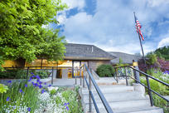 | 1135 South 2100 East | 84108 | (801) 594-8611 | No email listed; message box provided  http://www.slcpl.org/ | M-Th 10a-9p  F&Sa 10a-6p
Salt Lake City | Salt Lake City Public Library – Chapman  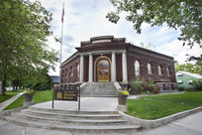 | 577 South 900 West | 84104 | (801) 594-8623 | No email listed; message box provided  http://www.slcpl.org/ | M-F 11a-8p  Sa 10a-7p  Su 12p-6p
Salt Lake City | Salt Lake City Public Library - Corinne And Jack Sweet  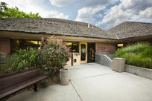 | 455 F Street (9th Avenue) | 84103 | (801) 594-8651 | No email listed; message box provided  http://www.slcpl.org/ | M-Th 10a-9p  F&Sa 10a-6p
Salt Lake City | Salt Lake City Public Library - Day-Riverside  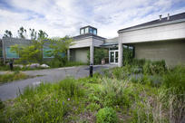 | 1575 West 1000 North | 84116 | (801) 594-8632 | No email listed; message box provided  http://www.slcpl.org/ | M-Th 10a-9p  F&Sa 10a-6p  Su 1p-5p
Salt Lake City | Salt Lake City Public Library – Glendale  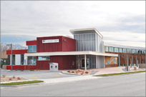 | 1375 South Concord (1240 West) | 84107 | (801) 594-8660 | No email listed; message box provided  http://www.slcpl.org/ | M-Th 10a-9p  F&Sa 10a-6p  Su 1p-5p
Salt Lake City | Salt Lake City Public Library – Marmalade  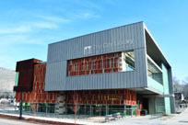 | 280 West 500 North | 84107 | (801) 594-8680 | No email listed; message box provided  http://www.slcpl.org/ | M-Th 10a-9p  F&Sa 10a-6p
Salt Lake City | Salt Lake City Public Library – Sprague  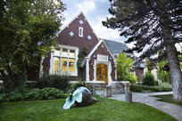 | 2131 South 1100 East | 84106 | (801) 594-8640 | No email listed; message box provided  http://www.slcpl.org/ | M-Th 10a-9p  F&Sa 10a-6p  Su 1p-5p
Salt Lake City | Salt Lake County Library – (Calvin S.) Smith Library 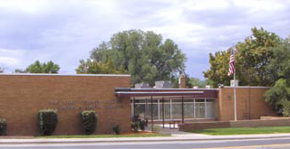 | 810 East 3300 South | 84106 | (801) 943-4636 | No email listed  http://www.slcolibrary.org/gl/glal/librarySmith.htm | M-Th 10a-9p;  F&Sat 10a-6p
Sandy | Salt Lake County Library - Sandy Library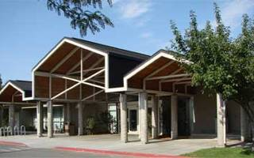 | 10100 South Petunia Way (1450 East) | 84092 | (801) 943-4636 | No email listed  http://www.slcolibrary.org/gl/glal/librarySandy.htm | M-Th 10a-9p;  F&Sat 10a-6p
Santaquin | Santaquin City Library  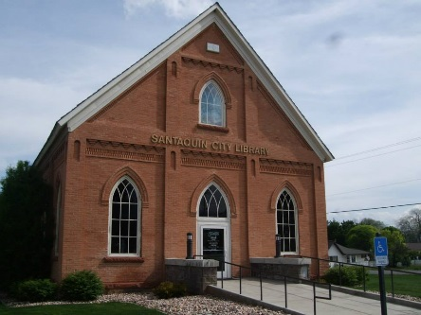 | 20 West 100 South | 84655 | (801) 754-3030 | No email listed  http://www.santaquin.org/index.php/component/content/article/54-leisure-services/library/318-library-main-5 | M-Th 12p-7:45p  F 12p-4:45p  Sa 10a-1:45p
Smithfield | Smithfield Library  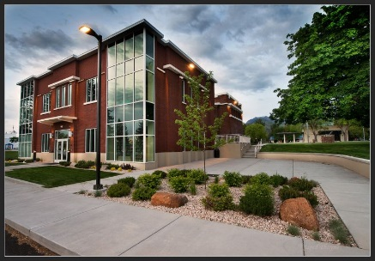 | 25 North Main Street | 84335 | (435) 563-3555 | http://www.smithfieldcity.org/library.main.html | M-Th 11a-7p  F 2:30p-5p  Sat 11a-3p
South Jordan | Salt Lake County Library - South Jordan Library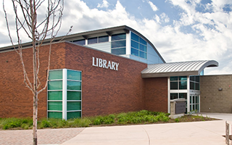 | 10673 South Redwood Road | 84095 | (801) 943-4636 | No email listed  http://www.slcolibrary.org/gl/glal/librarySouthJordan.htm | M-Th 10a-9p;  F&Sat 10a-6p
South Salt Lake City | Salt Lake County Library - Columbus Library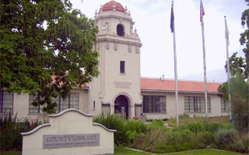 | 2530 South 500 East | 84106 | (801) 943-4636 | No email listed  http://www.slcolibrary.org/gl/glal/libraryColumbus.htm | M-Th 10a-9p;  F&Sat 10a-6p
Spanish Fork | Spanish Fork Public Library  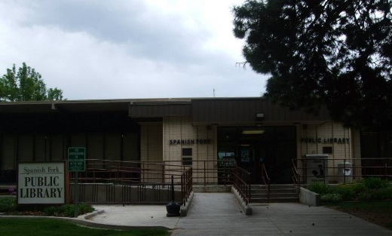 | 49 South Main Street | 84660 | (801) 804-4480 | No email listed  http://www.spanishfork.org/dept/library/ | M-Th 10a-8p  F&Sa 12p-6p
Springdale | Washington County Library - Springdale Branch  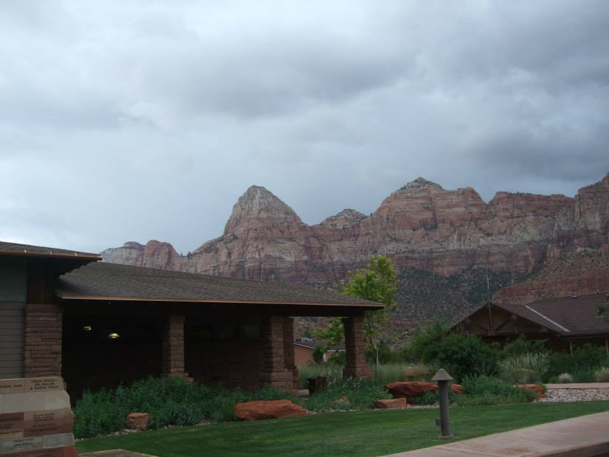 | 126 Lion Blvd.  PO Box 479 | 84767 | (435) 772-3676 | No email listed  http://library.washco.utah.gov/springdale/ | M-Th 10a-7p  F 10a-5p  Sat 12p-5p
Springville | Springville Public Library  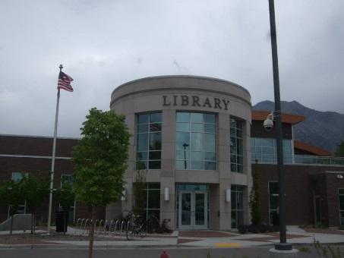 | 45 South Main Street | 84663 | (801) 489-2720 | No email listed; message  Box provided; staff emails listed  https://www.springville.org/library/ | M-Th 10a-9p  F 10a-6p  Sa 10a-4p
St. George | Washington County Library - Santa Clara Branch  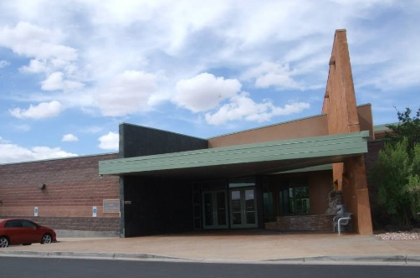 | 1099 North Lava Flow Drive | 84770 | (435) 986-0432 | No email listed  http://library.washco.utah.gov/santa-clara/ | M-Th 10a-7p  F&Sat 10a-6p
St. George | Washington County Library - St. George Main Branch  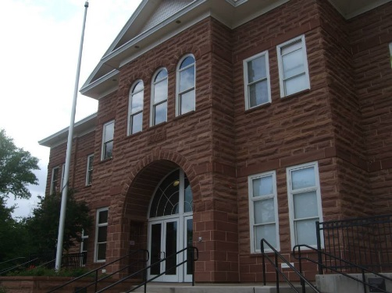 | 88 West 100 South | 84770 | (435) 634-5737 | No email listed  http://library.washco.utah.gov/st-george/ | M-Th 10a-8p  F&Sat 10a-6p
Syracuse | Davis County Library - Northwest Branch (Syracuse)  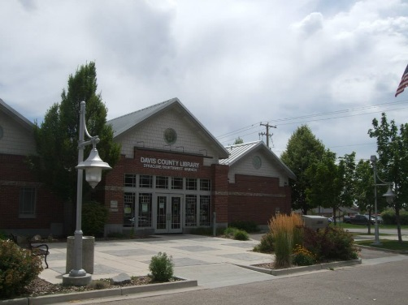 | 1875 South 2000 West | 84075 | (801) 825-7080 | library@daviscountyutah.gov  http://www.daviscountyutah.gov/library/library/locations/syracuse-branch | M-Th 10am-9pm  Fri & Sat 10a-6p
Taylorsville | Salt Lake County Library - Taylorsville Library 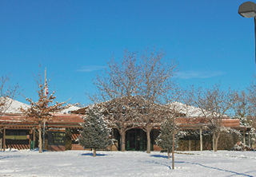 | 4870 South 2700 West | 84118 | (801) 943-4636 | No email listed  http://www.slcolibrary.org/gl/glal/libraryTaylorsville.htm | M-Th 10a-9p;  F&Sat 10a-6p
Tooele | Tooele City Public Library  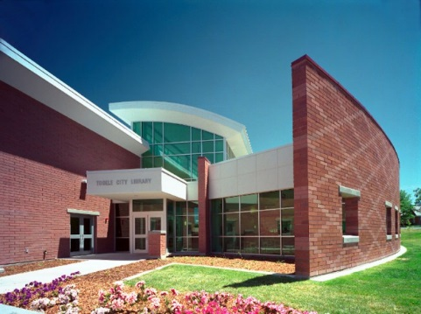 | 128 West Vine Street | 84074 | (435) 882-2182 | askalibrarian@tooelecity.org  http://tooelecity.org/city-departments/library/ | M-Th 10a-8p  F 10a-6p  Sa 10a-2p
Tremonton | Tremonton City Library  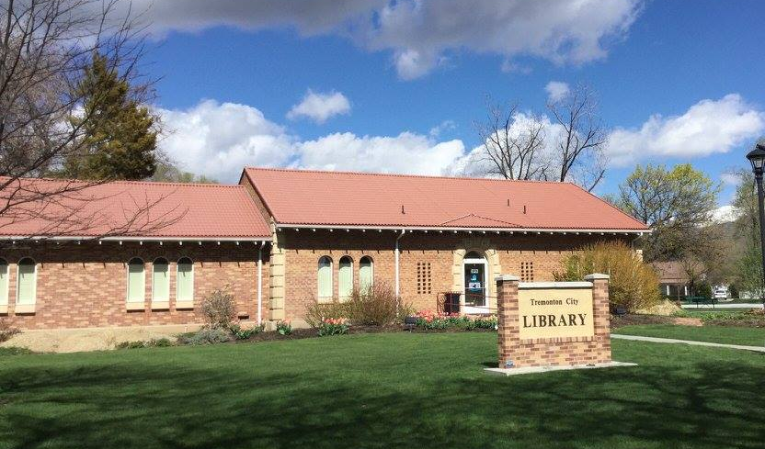 | 210 North Tremont Street | 84337 | (435) 257-9525 | library@tremontoncity.com  http://www.tremontonlibrary.org/ | M-Th 1p-8p  F 10a-7p  Sa 9a-3p
Vernal | Uintah County Library  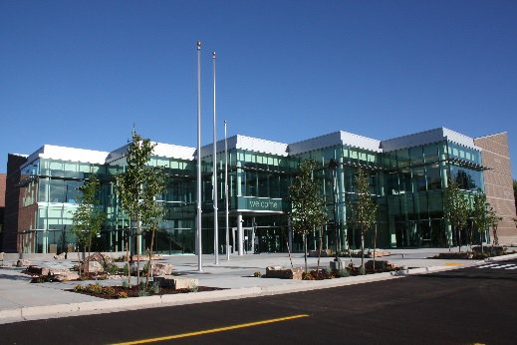 | 204 East 100 North | 84078 | (435) 789-0091 | No email listed; staff emails listed  https://uintahlibrary.org/ | M-Th 9a-9p  F&Sa 9a-6p
Washington | Washington County Library - Washington Branch  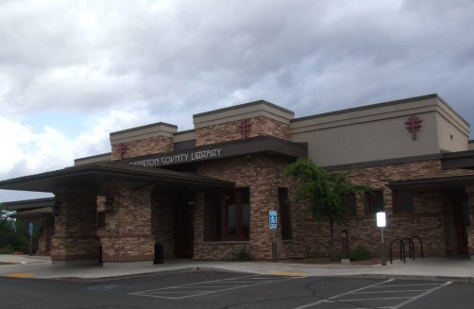 | 220 N 300 E | 84780 | (435) 627-2706 | No email listed  http://library.washco.utah.gov/washington/ | M-Th 10a-7p  F&Sat 10a-6p
West Jordan | Salt Lake County Library - Bingham Creek Library 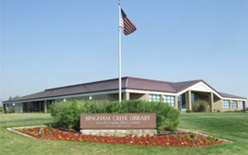 | 4834 West 9000 South | 84081 | (801) 943-4636 | No email listed  http://www.slcolibrary.org/gl/glal/libraryBinghamCreek.htm | M-Th 10a-9p;  F&Sat 10a-6p
West Jordan | Salt Lake County Library - West Jordan Library (& Administration offices)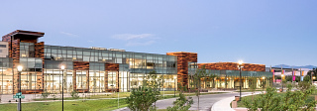 | 8030 South 1825 West | 84088 | (801) 943-4636 | No email listed  http://www.slcolibrary.org/gl/glal/libraryWestJordan.htm | M-Th 10a-9p;  F&Sat 10a-6p
West Jordan | Salt Lake County Library System – Viridian Event Center | 8030 S. 1825 W. | 84088 | (801) 948-7858 | No email listed  http://www.slcolibrary.org/gl/glal/eventCenterViridian.htm | Business Office  Hours: M-Th  10a-5p
West Valley City | Salt Lake County Library - Hunter Library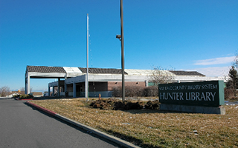 | 4740 West 4100 South | 84120 | (801) 943-4636 | No email listed  http://www.slcolibrary.org/gl/glal/libraryHunter.htm | M-Th 10a-9p;  F&Sat 10a-6p
West Valley City | Salt Lake County Library - West Valley Library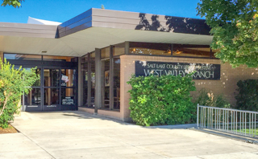 | 2880 West 3650 South | 84119 | (801) 943-4636 | No email listed  http://www.slcolibrary.org/gl/glal/libraryWestValley.htm | M-Th 10a-9p;  F&Sat 10a-6p
Willard | Box Elder County Bookmobile Library | 80 West 50 South  PO Box 595 | 84340 | (435) 723-2261 | No email listed; links to 2 drivers’ schedules  http://www.boxeldercounty.org/box-elder-county-bookmobile.htm | Not listed, but  drivers’ schedules  give an idea

